6A^{th} Grade: Unit 5, Lesson 5

- Based on the double number line, how many hours will it take to drive 195 kilometers?
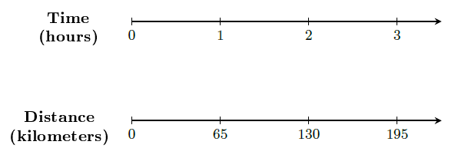

3 hours

- Tyler and Lara each went out for a run. Tyler ran 6 miles in 1 hour and Lara ran 10 miles in 2 hours. Who ran faster? Explain.

Tyler runs faster because his running rate (unit rate) is 6 miles per hour, while Lara runs at a rate of 5 miles per hour.

- Which is faster: 8 miles per hour or 36 miles in 4 hours?

8 miles per hour

